Report

|  |  |
| --- | --- |
| **Subject** | Planning Proposal to amend the Lismore Local Environmental Plan 2012 at 48 and 49 Lincoln Avenue, McLeans Ridges |
| **TRIM Record No** | BP20/199:AF19/3912 |
| **Prepared by** | Strategic Planning Project Officer |
| **Reason** | To seek a Council resolution to support an amendment of the Lismore Local Environmental Plan (LEP) at 48 and 49 Lincoln Avenue, McLeans Ridges for the purposes of seeking a Gateway Determination from the Department of Planning, Industry and Environment. |
| **Strategic Theme** | Our built environment |
| **Strategy** | Our land-use planning caters for all sectors of the community. |
| **Action** | Ensure a diverse range of land use and development opportunities are available. |

|  |
| --- |
| Executive Summary On September 13, 2019, Council received a draft Planning Proposal to amend the Local Environmental Plan (LEP) to:   * rezone the land at 48 Lincoln Avenue, McLeans Ridges (Lot 13 DP 1130169) from RU1 Primary Production to R5 Large Lot Residential, reduce the minimum lot size from 40ha to 3ha and apply a height of building limit of 8.5m; and * increase the minimum lot size applying to the adjoining land at 49 Lincoln Avenue (Lot 14 DP 1130169) from 2ha to 3ha.   The Planning Proposal will be achieved via changes to the Lismore Local Environmental Plan 2012 (LEP) zoning, height of building and minimum lot size maps. No changes are required to the Lismore Local Environmental Plan written instrument. A development application was lodged simultaneously with the Planning Proposal for the subdivision of the two lots into three. Determination of the development application is subject to the completion of the proposed Local Environmental Plan Amendment.  An assessment of environmental and physical constraints supported by technical reporting has not revealed any significant impediments that cannot be resolved.  It is recommended that Council support the attached Planning Proposal for the purposes of seeking a Gateway Determination from the Department of Planning, Environment and Industry. |

*Do not delete this line*

Recommendation

|  |
| --- |
| That Council:   1. support the Planning Proposal for the purpose of seeking a Gateway Determination to amend the Lismore Local Environment Plan 2012 as detailed in Attachment 1 of this report. The proposal involves rezoning the land at 48 Lincoln Avenue, McLeans Ridges (Lot 13 DP 1130169) from RU1 Primary Production to R5 Large Lot Residential and amending the minimum lot size of the adjoining lot at 49 Lincoln Avenue (Lot 14 DP 1130169) from 2ha to 3ha; 2. forward the Planning Proposal to the Department of Planning, Industry and Environment with a request for a Gateway Determination; 3. agree that staff place the Planning Proposal on public exhibition and consult with government agencies in accordance with a Gateway Determination and report back to Council any issues raised by government agencies and in public submissions during public exhibition. |

*Do not delete this line*

Background

On September 13, 2019, Council received a draft Planning Proposal to rezone the land at 48 Lincoln Avenue, McLeans Ridges (Lot 13 DP 1130169) from RU1 Primary Production to R5 Large Lot Residential, decrease the minimum lot size from 40ha to 3ha and introduce a height of building limit of 8.5m.

The Planning Proposal also seeks a change to the minimum lot size of the adjoining lot at 49 Lincoln Avenue (Lot 14 DP 1130169) from 2ha to 3 ha to facilitate a future subdivision of the two (2) lots into three (3) for residential use. A development application was lodged simultaneously with the planning proposal, however can only be considered after completion of the proposed LEP amendments.

The change to the minimum lot size at 49 Lincoln Ave to 3ha is required to achieve a consistent minimum lot size across the two sites to allow for a realignment of the current boundaries and to ensure no further subdivision is possible in the future. The total area of both parcels of land is 10.89ha. The proposed LEP amendments would allow for the creation of one (1) additional lot. This report only considers the proposed LEP amendments.

The site and location

The parcel of land at 48 Lincoln Avenue is approximately 9.58 hectares. An area in the north of the site of approximately 1 hectare has been cleared, with the remainder of the land covered in regrowth forest dominated by Camphor Laurel. The land slopes gently from south to north and steeply to the west at 20-33%. No buildings or other structures are located on the land.

The parcel at 49 Lincoln Avenue is vacant land that is part of the Floreat Park residential estate. It is zoned R5 and has an area of 1.31ha. Lands to the north, east and south of the site are currently zoned R5 Large Lot Residential and have been developed as part of the Floreat Park residential estate. Land to the west is predominantly zoned RU1 Primary Production, with some R5 Large Lot Residential land accessed from Whispering Valley Drive, Richmond Hill, as shown in Figure 1 (below).

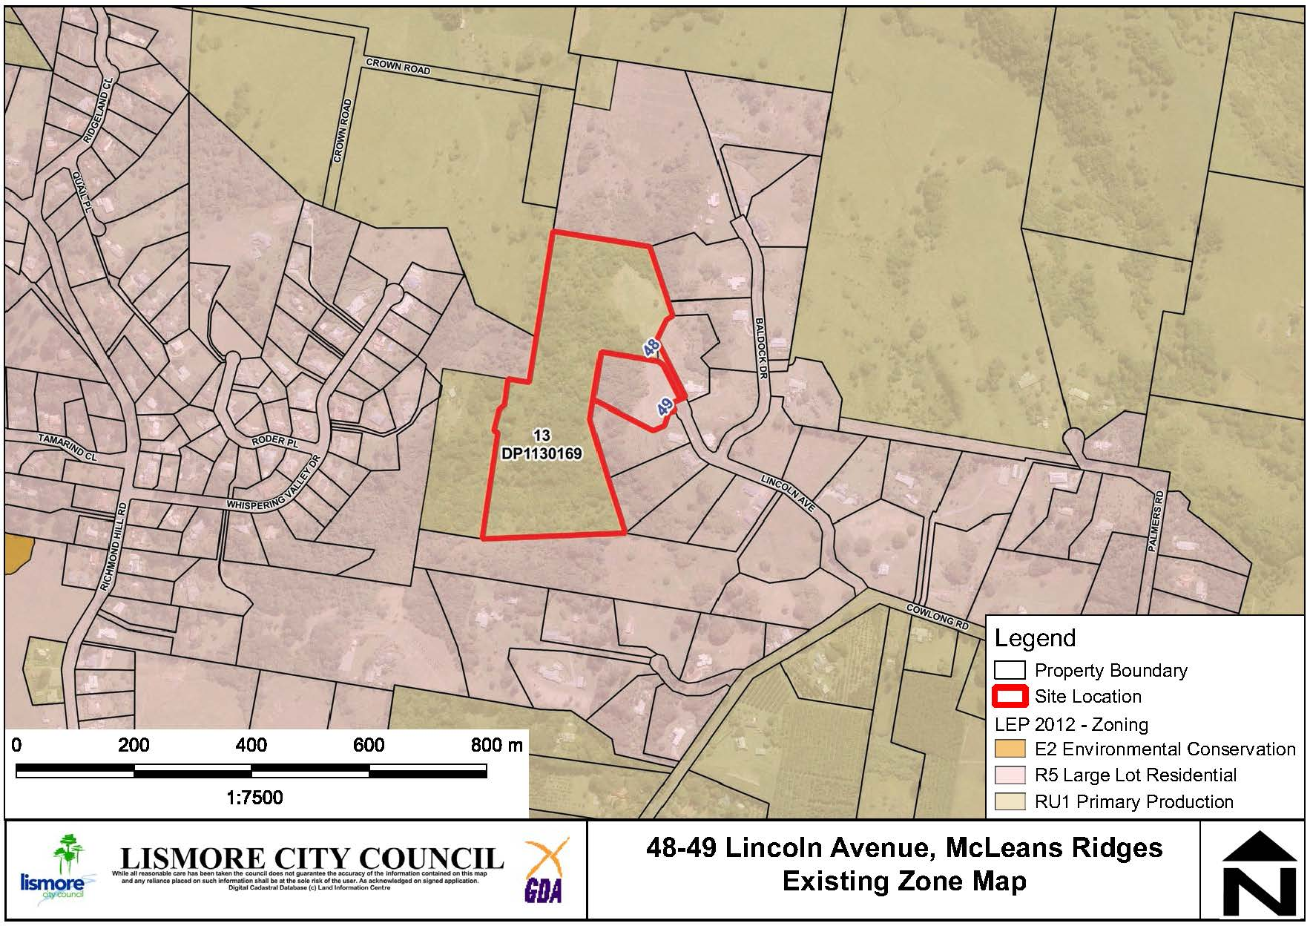

**Figure 1 – Location and existing LEP Zone map.**

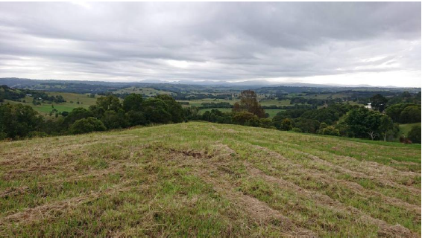

**Figure 2: Cleared land, looking north (48 Lincoln Avenue).**

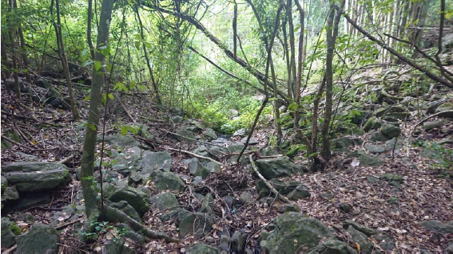

**Figure 3: General view of regrowth forest area.**

The site is identified in Council’s Growth Management Strategy (GMS) as being a potential site for future large lot residential development. The lot directly to the north has already been rezoned via a previous Planning Proposal and a development application for subdivision to create one additional lot has also been approved.

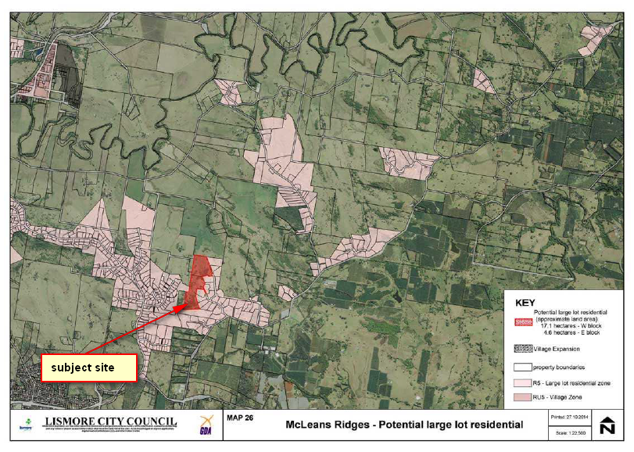

**Figure 4: Lismore Growth Management Strategy (2015-2035) map showing the subject site.**

Environmental, Social and Economic Impact Assessment

Environmental and physical constraints

**Threatened Flora / Vegetation Communities**

An ecological assessment was undertaken by Melaleuca Group and no threatened species or EECs were recorded during their investigations. It was noted that it is possible that some species may occur within the forested areas of the site, but any future residential dwellings will have to be located well outside of the forested areas due to slope and other constraints. Therefore, it is reasonable to conclude there will be no impact upon any potential species located within those areas.

**Contaminated Land**

A preliminary contaminated land assessment was undertaken by Melaleuca Group Pty Ltd and submitted with the Planning Proposal. It covered the area of land shown to be the indicative dwelling envelope area submitted with the development application. No chemicals of concern have been identified above threshold levels for residential use.

**Bushfire**

The site is mapped as containing bushfire prone vegetation as shown in Figure 5. Both Category 1 and Category 2 vegetation is mapped across the site. A preliminary assessment of bushfire hazard indicates that future development will be able to meet the requirements of Planning for Bushfire Protection 2006. As the site is mapped as bushfire prone land, the Planning Proposal will require referral to the NSW Rural Fire Service.

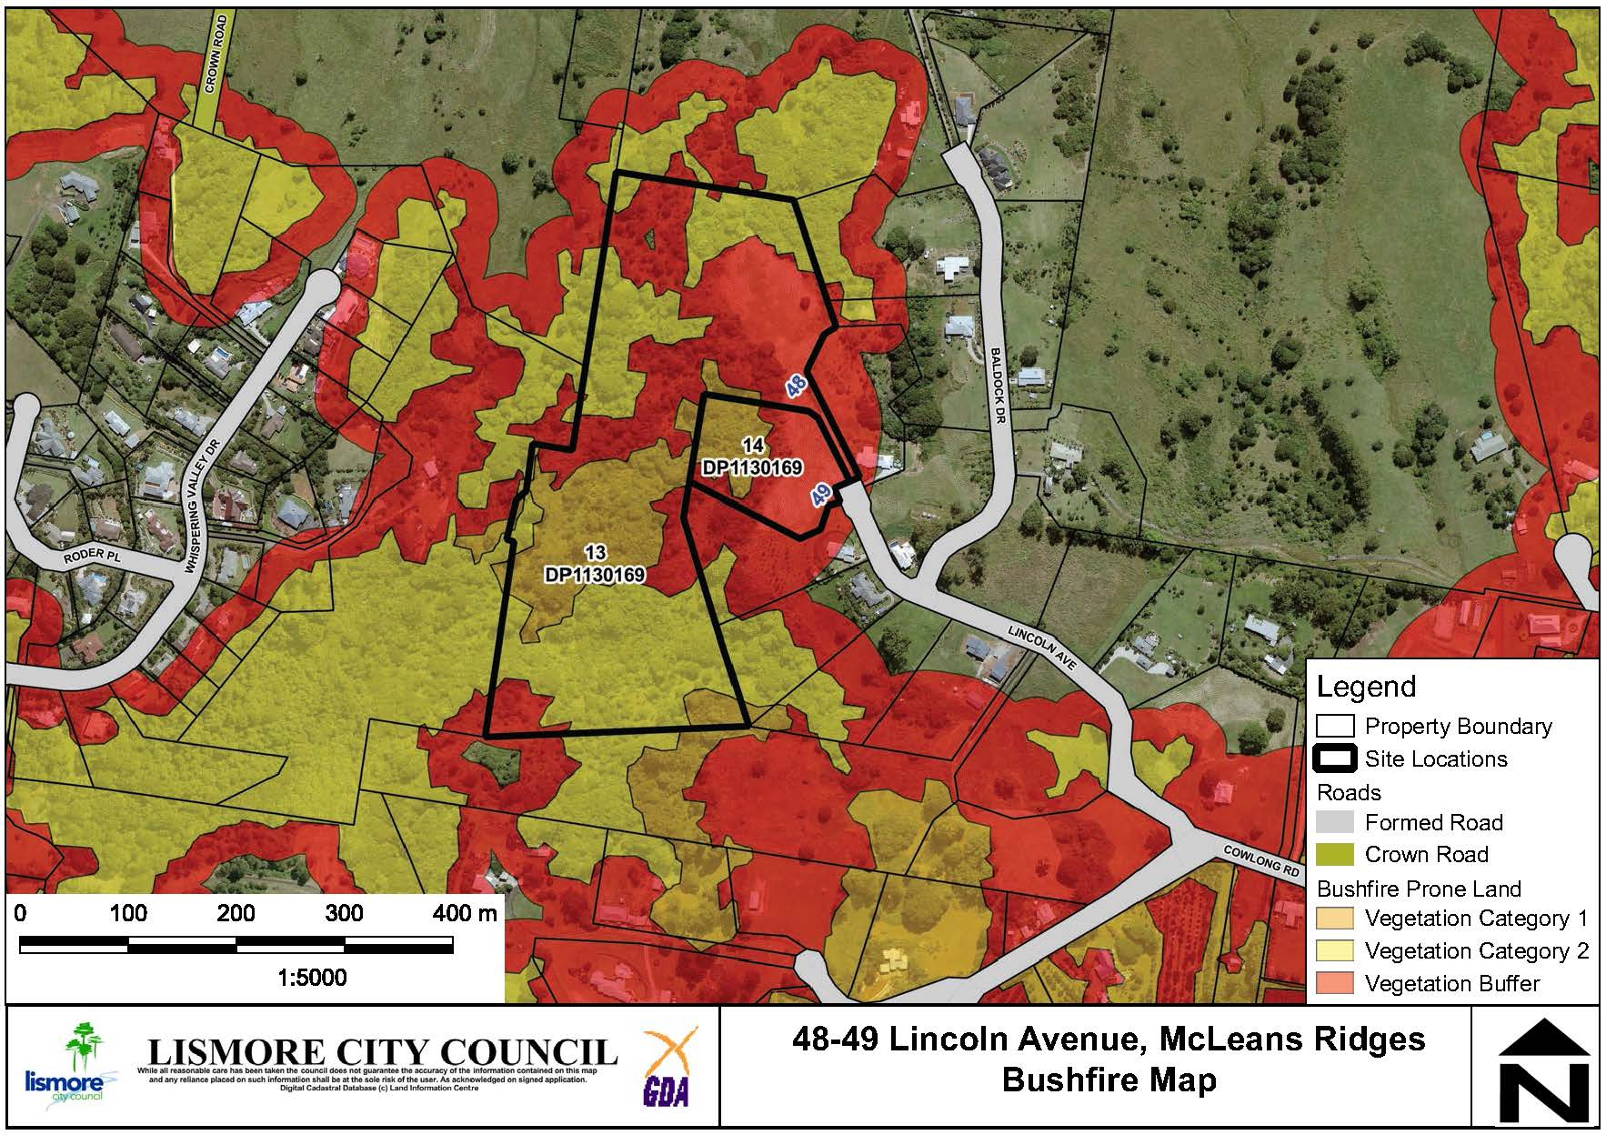

**Figure 5: Bushfire vegetation mapping**

**Watercourses**

A second and third order stream are in the south western part of the site. The NSW Office of Water recommends a riparian buffer of 20 metres and 30 metres respectively to preserve the integrity of the riparian corridor. Given the slope of the land, any future dwellings will be situated more than 200 metres from the watercourse. Figure 6 below shows the watercourses as a dark blue dotted line with indicative building envelopes well clear of any buffer requirements.

**Stormwater management**

Given the scale and location of the proposed LEP amendment, consideration of stormwater disposal can reasonably be determined and managed at the future subdivision stage.

**Land Use Conflict**

The proposed LEP amendment will result in the interface of a rural residential land use with an existing rural land use. While there are no existing agricultural activities currently being undertaken on the adjoining land, a Land Use Conflict Risk Assessment (LUCRA) may be required with a future development application for a dwelling.

**Slope**

The land is constrained by the slope of the land which is particularly steep (20-33%) to the west. The applicant has provided a map, Figure 6 below, showing an indicative lot layout with building envelopes and on-site sewage management systems that comply with Council requirements located on a gentle slope of around 15-20% on the ridgeline area that has been cleared of vegetation.

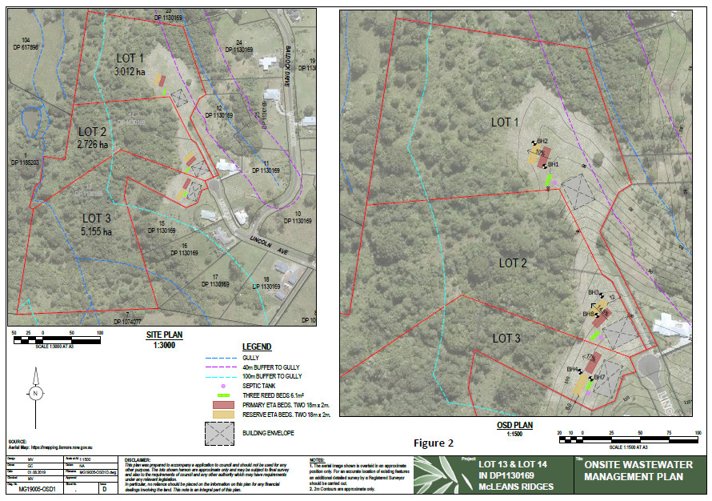

**Figure 6: Indicative lot layout and building envelopes.**

A review of the files of past subdivision developments in the vicinity did not identify slope instability as an issue. Whilst it is likely slope stability should not be an issue, an assessment may be required with future development applications for a dwelling.

Social, economic and cultural heritage impacts

**Aboriginal and European Cultural Heritage**

An Aboriginal Heritage Information Management Systems (AHIMS) search of the site and surrounding area was conducted. No Aboriginal sites were identified. A referral was also sent to the Ngulingah Local Aboriginal Land Council. The LALC recommended that any future development applications that propose excavation works within gully areas should include on-site cultural spotters. Whilst indicative future building envelopes and on-site sewage management systems have been identified well away from gully areas, this advice is noted and should be considered with any future development applications.

**Economic Impacts**

The planning proposal will facilitate the development of one additional lot which is unlikely to create any adverse economic effects. There is likely to be some additional economic activity generated by development of the land and construction of future dwellings.

**Social Impacts**

Due to the nature and scale of the proposal there are not expected to be any adverse social impacts. A social impact assessment is not triggered by LCC’s policy as the proposed rezoning will result in less than 20 dwellings. The provision of additional land for residential development will increase housing choice in the Lismore LGA.

Servicing and infrastructure

**Road Network**

The site has existing access to Lincoln Road. Council’s strategic engineer is satisfied the local road network is able to cope with the expected increase in traffic.

**Water and sewer**

No reticulated water or sewage is provided within the existing residential estate. All residents are required to supply rainwater tanks and on-site sewage management systems. These requirements can be dealt with at a future DA stage.

**Education, Health and Emergency Services**

The site is located approximately 12kms by road from the Lismore CBD and the Base Hospital and allied health services, various primary and secondary schools, Southern Cross University and emergency services.

Overview of the Planning Proposal

It is proposed to amend the Lismore LEP to:

* rezone the land at 48 Lincoln Avenue, McLeans Ridges from zone RU1 Primary Production to zone R5 Large Lot Residential;
* reduce the minimum lot size applying to 48 Lincoln Avenue, McLeans Ridges from 40ha to 3ha;
* impose a height of building limit of 8.5m to 48 Lincoln Avenue, McLeans Ridges; and
* increase the minimum lot size for 49 Lincoln Avenue, McLeans Ridges (Lot 14 DP 1130169 2ha to 3ha.

This will be achieved by amending map sheets: LZN_005, LSZ_005 and HOB_005 as shown in Figures 7 - 12.

No changes are required to the Lismore LEP 2012 written instrument.



**Figure 7: Existing Land Zoning**

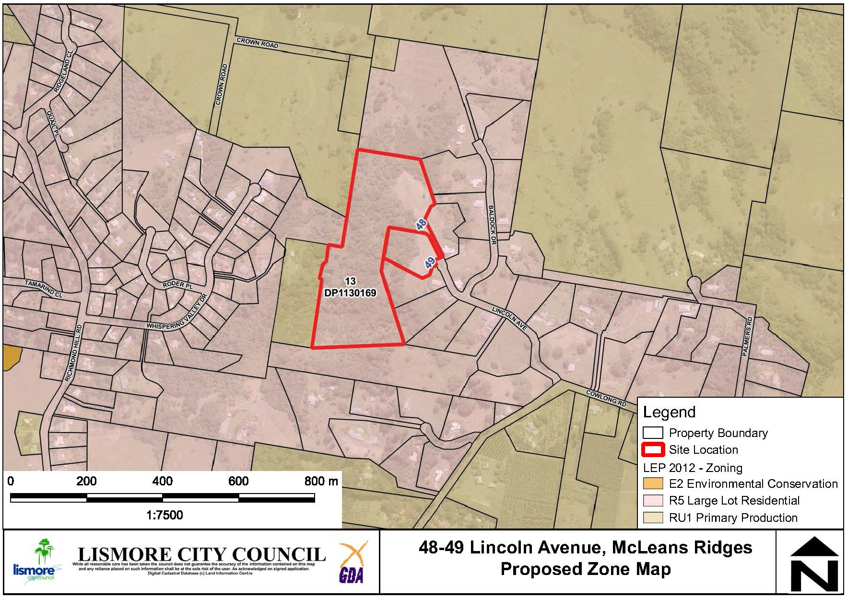

**Figure 8: Proposed Land Zoning**

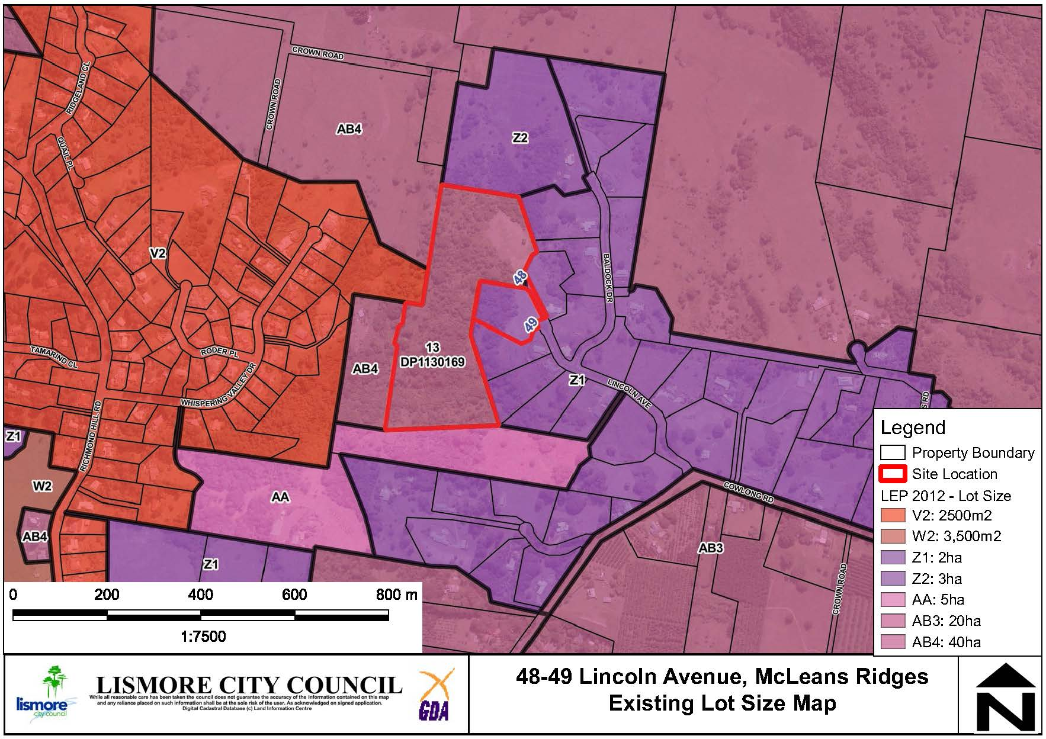

**Figure 9: Existing Minimum Lot Size**

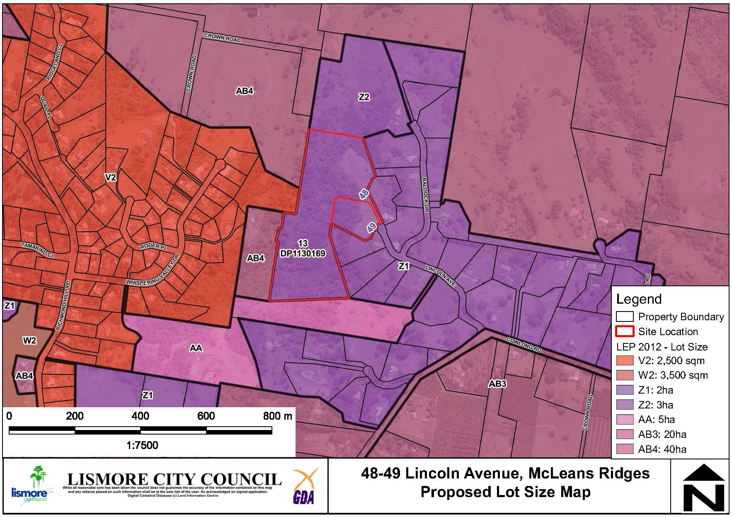

**Figure 10: Proposed Minimum Lot Size** **includes a change to 49 Lincoln Avenue to 3ha.**

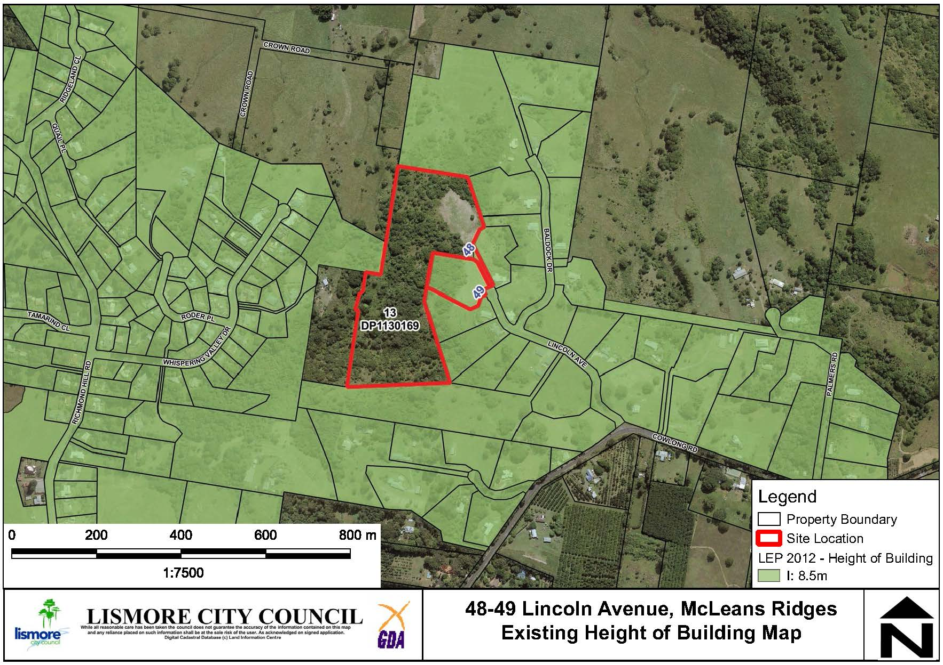

**Figure 11: Existing Height of Buildings**

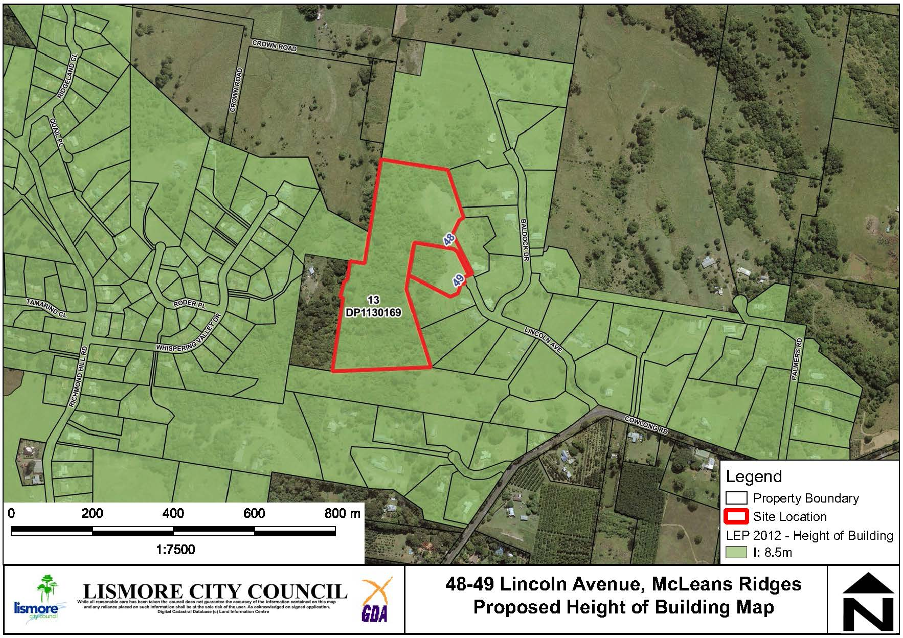

**Figure 12: Proposed Height of Buildings**

Table 1 provides a summary of the planning proposal.

**Table 1: Summary of Planning Proposal**

| **PART** | **REQUIREMENTS** | **DESCRIPTION OF PLANNING PROPOSAL** |
| --- | --- | --- |
| 1 | **OBJECTIVES OR INTENDED OUTCOMES** | The objective of this planning proposal is to rezone land at 48 Lincoln Avenue, McLeans Ridges (Lot 13 DP 1130169) from Zone RU1 Primary Production to Zone R5 Large Lot Residential, with associated changes to the MLS and HOB maps, and to change the minimum lot size for 49 Lincoln Avenue (Lot 14 DP 1130169) from 2ha to 3ha. The proposal is aimed at facilitating the future subdivision of the land to create one additional lot for residential development. |
| 2 | **EXPLANATION OF PROVISIONS** | The planning proposal seeks to amend the following parts of the Lismore LEP 2012:  Map sheets: LZN_005, LSZ_005 and HOB_005.  No changes are required to the Lismore LEP 2012 written instrument. |
| 3 | **JUSTIFICATION**  **Section A- Need for the Planning Proposal**  ***Is the planning proposal a result of any strategic study or report?***  ***Is the planning proposal the best means of achieving the objectives or intended outcomes, or is there a better way?*** | The subject site is identified within Lismore’s Growth Management Strategy as an area for potential large lot residential rezoning.  A planning proposal to rezone the land and amend the lot size of the adjoining land at 49 Lincoln Avenue is considered the most appropriate means of enabling the development of the land. |
| 4 | **JUSTIFICATION**  **Section B- Relationship to Strategic Planning Framework**  ***Is the Planning Proposal consistent with the objectives and actions contained within the applicable regional or sub-regional strategy?***  ***Is the Planning Proposal consistent with the Council’s local strategy or other local strategic plan?***  ***Is the Planning Proposal consistent with applicable State Environmental Planning Policies (SEPP)?***  ***Is the Planning Proposal consistent with applicable s9.1 Ministerial Directions?*** | The NCRP is the overarching State Government framework to sustainably manage growth for the Far North Coast. The NCRP states that ‘local growth management strategies will be prepared by councils to reflect the directions and actions contained in this Plan.’ The planning proposal is consistent with the goals and actions of the NCRP with regard to locating new housing in and around existing towns where essential services and road infrastructure has been established.  The NCRP also states that well-planned rural residential housing will be achieved by ‘*identifying new rural residential areas in a local growth management strategy or rural residential land release strategy endorsed by the Department of Planning and Environment’*.  This Planning Proposal is consistent with this action in the NCRP.  The Planning Proposal is also consistent with the following strategic planning documents:   * Imagine Lismore (Community Strategic Plan 2017-2027) * Lismore Growth Management Strategy 2015-2035 (GMS)   The Planning Proposal is consistent with applicable SEPPs as outlined in Appendix 1.  The Planning Proposal is consistent with applicable Section 9.1 Directions or any inconsistency can be justified, as outlined in Appendix 2. |
| 5 | **JUSTIFICATION**  **Section C- Environment, Social and Economic Impact**  ***Is there any likelihood that critical habitat of threatened species, populations or ecological communities or their habitats, will be adversely affected as a result of the proposal?***  ***Are there any likely environmental effects as a result of the Planning Proposal and how are they proposed to be managed?***  ***Has the Planning Proposal adequately addressed any social and economic effects?*** | No threatened species or EECs were recorded at the site and any future dwellings will be located away from forested areas of the site.  Minimal environmental, economic or social impacts are anticipated. |
| 6 | **JUSTIFICATION**  **Section D - State and Commonwealth Interests**  ***Is there adequate public infrastructure for the Planning Proposal?***  ***What are the views of State and Commonwealth public authorities consulted in accordance with the Gateway Determination?*** | Council staff have carried out a preliminary assessment of public infrastructure and determined that Lincoln Avenue can adequately cater for the expected increase in vehicle movements. Reticulated water and sewage services are not available and will be required to be provided with any future development application for a dwelling.  It is recommended that the following authorities are consulted following the Gateway determination:   * Rural Fire Service * Biodiversity and Conservation Division (DoPIE) * Department of Primary Industries |
| 7 | **MAPPING** | It is proposed to amend the LEP maps as shown in Figures 7-12 above in this report. |
| 8 | **COMMUNITY CONSULTATION** | A 28-day community consultation period is recommended but this will be confirmed in the Gateway determination. |
| 9 | **PROJECT TIMELINE** | Recommendation of approximately 8 months to complete.  Refer to Attachment 1 for detail. |
| 10 | **DELEGATIONS** | Recommendation for Council to exercise plan making delegations. |

Comments

Finance

Finance have noted the report and believe there is no material financial impact to Council.

Other staff comments

Council’s specialist staff have assessed the Planning Proposal as required and their comments are incorporated into the relevant sections of this report.

Public consultation

Council will carry out consultation with the community following Gateway Determination. For the purposes of public notification, Council considers that a twenty-eight (28) day public exhibition period is appropriate.

Notification of the exhibited Planning Proposal will include:

* A newspaper advertisement (Local Matters) that circulates in the area affected by the Planning Proposal.
* The website of Lismore City Council and the Department of Planning, Industry and Environment.
* Correspondence to adjoining landholders.

The written notice will:

* Provide a brief description of the objectives or intended outcomes of the Planning Proposal.
* Indicate the land that is the subject of the Planning Proposal.
* State where and when the Planning Proposal can be inspected.
* Provide detail that will enable members of the community to make a submission.

Exhibition Material:

* The Planning Proposal, in the form approved for community consultation by the Director General of the Department of Planning, Industry and Environment.
* The Gateway Determination.
* Any studies required as part of the Planning Proposal.

The Gateway Determination will confirm the public consultation requirements.

LEP delegations

Council resolved at its ordinary meeting of 11 December 2012 to accept the delegations which enable it to process the final stages of a planning proposal (LEP amendment). The delegations only extend to minor and routine LEPs. Delegations will be confirmed as part of the Gateway determination.

Conclusion

A preliminary assessment of the Planning Proposal and a constraints analysis of the subject site has not revealed any significant impediments to proceeding to the Gateway stage. The Planning Proposal is generally consistent with relevant State Environmental Planning Policies and s9.1 Ministerial Directions and any inconsistencies can be justified. There is enough information to enable Council to support the Planning Proposal and forward it to the Department of Planning and Environment for a Gateway Determination.

*Do not delete this line*

## Attachment/s

|  |  |  |
| --- | --- | --- |
| 1. | Planning Proposal 48 Lincoln Avenue | (Over 7 pages) |